|  |  |
| --- | --- |
|  | Sant Gajanan Maharaj Rural Hospital & Research Center  SANT GAJANAN MAHARAJ COLLEGE OF ENGINEERING  **DEPARTMENT OF COMPUTER SCIENCE AND ENGINEERING** |
| Academic year: **2021-22** Subject: Project Class: B.E.CSE  **SYNOPSIS** |
| **Project Identification No: Date:** | |

**1. Project Title:** Online Shopping System with Targeted Advertisement using Token and Encrypted Feedback**.**



**2. Project sponsored by:** Usha Vahini Masale, Kankavli. Dist. Sindhudurg.

**E-mail:** ushafoodprocessing@gmail.com

**3. Abstract:**

The objective of this project is to develop a general-purpose online store where the products can be brought from the comfort of home through the internet. This system stores the list of products, price, list of products are organized by category and successful delivery of the product from warehouse the customer will get notification. The customer will get notifications of newly added products and discount offers. Shopping has been a favorite pastime activity for quite some time. We have removed key drawbacks of previously existing solution. Our proposed idea has online booking of the products from the comfort of home through the internet. This system stores the list of products, price, list of products are organized by category and successful delivery of the product from warehouse the customer will get notification, online payment and advertisement. If the admin launches new product, then the client get the notification and can book their orders.

**4. Introduction:**  The online store is a virtual store on internet where customers can browse the catalog and select products they want to buy. The selected item may be selected in a shopping cart. At checkout time, the items in the shopping cart will be presented as an order. At that time more information will be needed to complete the transaction. Usually, the customer will be asked to fill or select a shipping address, and the payment information such as credit card number. A notification is sent to the customer as soon as the order is placed. Now a days everything has become online from online booking of parking space, online education, ticket booking and also online marketing. but in some part of country online marketing is not held, still some production factories forwards are maintained the factory registers to an order, balance sheets are not maintained properly. They cannot track orders and there is fraudulent in payments, small spelling mistake in inserting the addressing of the clients can misplace the products related to orders. factories are unable to showcase newly launched products there is difficulty in tracking order s or identifying user lots of miscommunication between the accountant and warehouse employee to conform the orders a behalf of owner.

**5. Proposed work:** The main purpose of the system is digitalization in marketing. This system will store all the data related to orders and payment. The consumers will get notifications of newly launched products and offers. The payment history of wholesalers, retailers and the consumers will be sorted separately. The owner can track the user and orders. Here we have two main panel client side and admin side.

**Client side:** We will have registration for new customers. In that we need to choose wholesaler, retailer, consumer. Based on the selection of the customer they need to upload their license. Add the shop address, pin code, state, city. They need to set password.

**Admin side:** Firstly, admin need to register his details like email phone number, password, address. After successfully registration he need to login by putting the email/mobile number and password. After login they will get dashboard, where they can see users (name, contact, rate). On that dashboard he can upload product details like name of product, quantity, weight, image, video, description, rate. They on put product details category while (veg, non-veg, premix, and view all). They can also upload advertisement like title, images and videos time of sale. Verifications are send to client from admin that order has been displaced or confirm order and if new product is launched the client get notification. Admin can see the order list date/month/year wise, sort wise and status.

**6. System Architecture:**

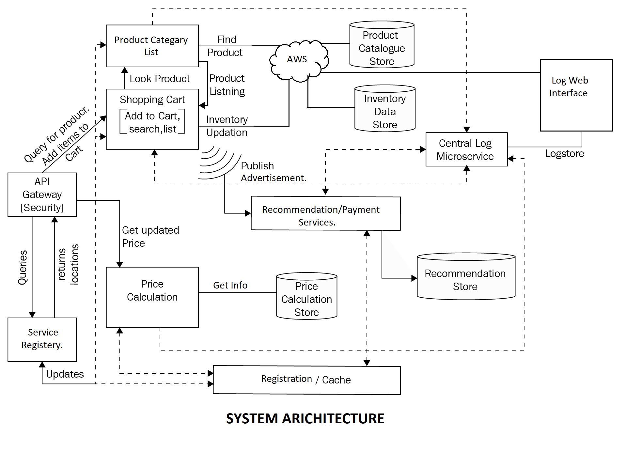



**Fig. SYSTEM ARCHITECTURE**



This system architecture represents Online Shopping System with Targeted Advertisement using Token and Encrypted Feedback**.** This architecture consists of main modules client, admin, payment gateway, AWS, advertisement modules. Advertisement module provides the product related offers and that offers stored to cloud. Orders are managed in admin side where admin can view (previous orders, pending orders and delivered orders) and maintain order status. We need to run our server to store the data. In this system AWS cloud is implemented for storing data.

**7. Flowchart:**

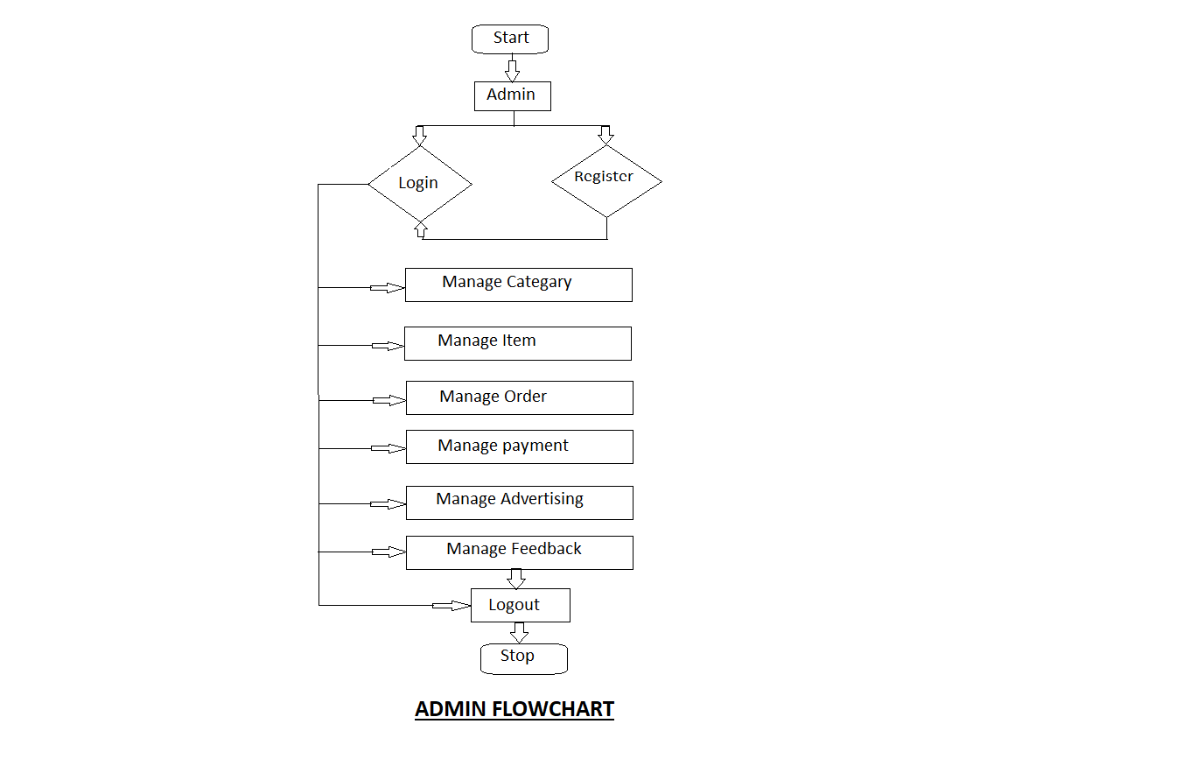

**Fig. ADMIN-SIDE FLOWCHART**

**Admin Side:** In the Admin side flowchart the admin needs to start the system firstly he needs to register and then login. Every time he need not have to register, login and start the system then admin side system will have dashboard from where the admin manages category, manage item, orders (pending orders, completed orders, ordered history). Manage payment, manage advertisement, manage feedback and admin can log out.

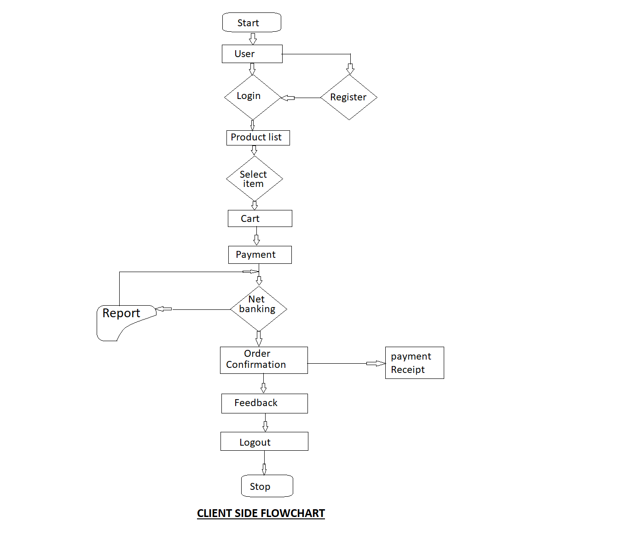



**Fig. CLIENT-SIDE FLOWCHART**

**Client side:** In above figure client-side flow chart. The client starts the system and goes to the login page and if the client is new then he needs to create the account by registration there and after successfully registration user need to log in and submit it the home screen or dashboard screen is displayed, here the user needs to select item, add to cart and pay for the product. Through net banking and if there is report occurred then it goes back to payment screen. Then after order configuration. Feedback screen comes and the user can logout.

**8. References, Literature reviews:**

1. Proceeding of 2018 IEEE International Conference on Current Trends toward Converging Technologies, Coimbatore, India 978-1-5386-3702-9/18/$31.00 © 2018 IEEE 1 Report on the Feasibility Study of E-Commerce Website Development for the Cooperative Store at College of Science and Technology.

**Abstract:** New emerging technology has led to astounding inventions. The main objective of this project is to identify the customer satisfaction towards the product. Descriptive research was used in this project. The project was based on the customer satisfaction of the product and performance of the customer to identify the competitors to provide suggest and to improve the quality of product. Now a days customers are facing lots of problems like they must go physically to the shop to buy the things and sometimes it get closed or remain out of stock. So we are launching this app to satisfaction of customers need.

1. Automated Shopping Cart Using RFID with a Collaborative Clustering Driven Recommendation System. Ruchi Gupte, Shambhavi Rege, Sarah Hawa, Dr. Y S Rao, Dr. Rajendra Sawant. Sardar Patel Institute of Technology, Bhartiya Vidya Bhavan’s Campus, Andheri, West Mumbai, India.

**Abstract:** The main purpose of this project is to demonstrate the incorporation of RFID technology which will not only make the billing easier but will also improve customer experience. The motive of this innovative system is to make shopping more comfortable for the customer. To track the order the customers this web application will provide an order number per order same as the common process of sone online shop. The application has a simple online marketing app for upgrade business level.

**9. Requirements:**

|  |  |
| --- | --- |
| **Hardware** | **Minimum requirement** |
| Disk space | 256GB or more. |
| RAM | 4GB |
| Display | (800 x 600) Capable video adapter and monitor. |
| Processor | 1.4GHz 64 bit. |

|  |  |
| --- | --- |
| **Software** | **Minimum requirement** |
| React-Native | 0.66 version |
| Nodejs | 14.17.0 version |
| MongoDB | 5.0.4 version |
| VS Code | 1.62.0 or more |

**10. Project Plan:**

|  |  |  |
| --- | --- | --- |
| **Month** | **Project work/plan** | **Remark** |
| September | Project Topic selection. |  |
| October | Planning and synopsis |  |
| November | Analysis and overview of project |  |
| December | Design of Module 1 |  |
| January | Coding of module 1 |  |
| February |  |  |
| March |  |  |
| April |  |  |
| May | Testing and debugging. |  |
| June | Project report |  |

Date:

Place: SGMCOE Mahagaon.

Name & Signature of the student:

1. Mr. Pratik Prakash Bodhe (Group Leader) _____________________

2. Mr. Sourav Umesh Ghorpade. _____________________

3. Ms. Janhavi Vivek Kokare. _____________________

4. Ms. Sayali Shashikant Patil. _____________________

Prof. P. R. Gadyanavar. Prof. S.S. Gurav. Prof. S. G. Swami.

**Project Guide Project Coordinator HOD (CSE)**